**Client Demo -3 Agenda**

Hi Jacob,

            Hope you are doing well. We are planning to have a client demo on Monday from 9:00 am to 9:50 am, Valk 117. Please let us know if you are available on Monday.

Here is the agenda for the meeting.

            The first 10 minutes are allotted to the presentation about the app.

|  |  |  |  |
| --- | --- | --- | --- |
| **Team Name** | **Presentation Description** | **Presenter** | **Time Slot** |
| Party Freaks | In this demo, we will present updated functionalities regarding master user which includes dynamic databinding, host user which includes host profile edit, create event and location change request, basic and guard user regarding edit profile in hosted website | Srichaitanya Peddinti | 9:10 – 9:16 |
| Invincible Techies | In this demo, we will show Basic User, Guard and Host screen flow. We integrated five web services provided by the web services team for login, registration, user info, university list and logout. | Bhavana Pilli | 9:16 – 9:22 |
| Bash Guardians | We will show demo on Basic User, Guard and Host user screens. We had integrated the web services provided by the Web Services team. | Yashwanth | 9:22 – 9:28 |
| Think Tank | In this demo, we will be showing Basic user core functionality, Updated user interface, And the added services for registration and login pages. | Nikhil Yerram | 9:28 – 9:34 |
| Android Nachos | 1. Show data from JSON files. 2. Show images from JSON files. 3. Select profile pic from gallery or camera. 4. Upload images to S3 bucket. 5. Basic user edit profile. | Rakshith & Ashish | 9:34 – 9:40 |
| Megatrons | In this presentation we will show you the services we have finished. Host user registration & login, basic user registration & login, Master user registration & login and Fraternity registration. | Manoj | 9:40 – 9:46 |

We have couple more demonstrations during the coming weeks. Here are the following dates for those demonstrations, so please let us know which dates work the best for you.

Demo 4:  10/31/2016 or 11/02/2016 or 11/04/2016 from 9:00 am to 9:50 am

Demo 5:  11/14/2016 or 11/16/2016 or 11/18/2016 from 9:00 am to 9:50 am

 Regards,

Vinod Kurma

S525039

**Client Meeting – 2 Agenda**

Hi Jacob,

                Hope you are doing well. We are planning to have a client demo this Friday from 9:00 am to 9:50 am. Please let us know if you are available on Friday.

Here is the agenda for the meeting.

|  |  |  |  |
| --- | --- | --- | --- |
| **Team Name** | **Presentation Description** | **Presenter** | **Time Slot** |
| Party Freaks | 1. Navigation of User Interface for all Users. 2. Demo of E-mail functionality on Homepage. 3. Demo of Google-maps functionality in getting location of the fraternity. 4. Will integrate our UI screens with some basic backend services like Login, Adding Customer, creating events. | Srichaitanya Peddinti | 9:00 – 9:10 |
| Invincible Techies | In this demo, we will show Guard screens and include functionality for User screen using sample data. | Bhavana Pilli | 9:10 – 9:20 |
| Bash Guardians | We are going to give demo on User Login, Registration and user interface screens of basic user and host user. | Sanjeev Koneru | 9:20 – 9:30 |
| Think Tank | 1. We have completed the User Interface for Basic user. 2. We also completed the User Interface for Host user part of the application. 3. All the Screens of both the users have be integrated. 4. We are planning to show the navigation of our application in the demo. | Nikhil Yerram | 9:30 – 9:40 |
| Android Nachos | Services team has created below list of services.   1. Login 2. Registration 3. Forgot Password   In this demo, we'll integrate our UI screens with some basic back-end services like login, registration and Forgot password. | Ashish Peruru | 9:40 – 9:50 |
| Megatrons | We will roll out the below services to be demoed with mobile clients   1. Login 2. Registration 3. Forgot password   We will show that they are able to consume our services which will be hosted in Azure | Manoj | 9:40 – 9:50 |

We are planning to have more demonstrations during the coming weeks. Here are the following dates for those demonstrations, so please let us know which dates work the best for you.

Demo 3:  10/17/2016 or 10/19/2016 or 10/21/2016 from 9:00 am to 9:50 am

Demo 4:  10/31/2016 or 11/02/2016 or 11/04/2016 from 9:00 am to 9:50 am

Demo 5:  11/14/2016 or 11/16/2016 or 11/18/2016 from 9:00 am to 9:50 am

Thanks & Reagrds,

Vinod Kurma

S525039

**Client Demo - 1 Agenda**

Hello Jacob,

Warm Greetings to you,

Firstly we would like to thank you for coming down for a meet, tomorrow we are going to present the PartyGuard project with respect to the teams, and their respective roles. I'm writing you to give a small glimpse over the agenda tomorrow.

**Location:**

Friday, Sept 16, 2016 - 9:00 AM

Location: Valk Building, Room - 117

**Attendees:**

-Client: Jacob Stansbury

-Professors: Dennis Case, Charles Hoot

-Course Assistant: Harish Kola, Priyanka Anjuri, Srujan Mathur Gade

-All the students working on the projects under different teams.

**Person running the client meeting:** Vinod Kumar Kurma

**Agenda Items:**                                                                                                          **Duration**

1) Application Demo

         - PartyGuard Web team : Nihitha, Abhisai                                                       6 mins

         - PartyGuard Android team : Rakshith, Nikhil                                                 6 mins

         - PartyGuard IOS team : Bhavana, Sanjeev                                                      6 mins

         - PartyGuard Web Services team : Prasunjit                                                    6 mins

2) Discuss the questionnaire with Jacob sent by Seshu                                        15 mins

3) Client Feedback                                                                                                       10 mins

Looking forward to a great day tomorrow.

Thank you,

Vinod Kumar Kurma

**Communication with client during GDP - 1**

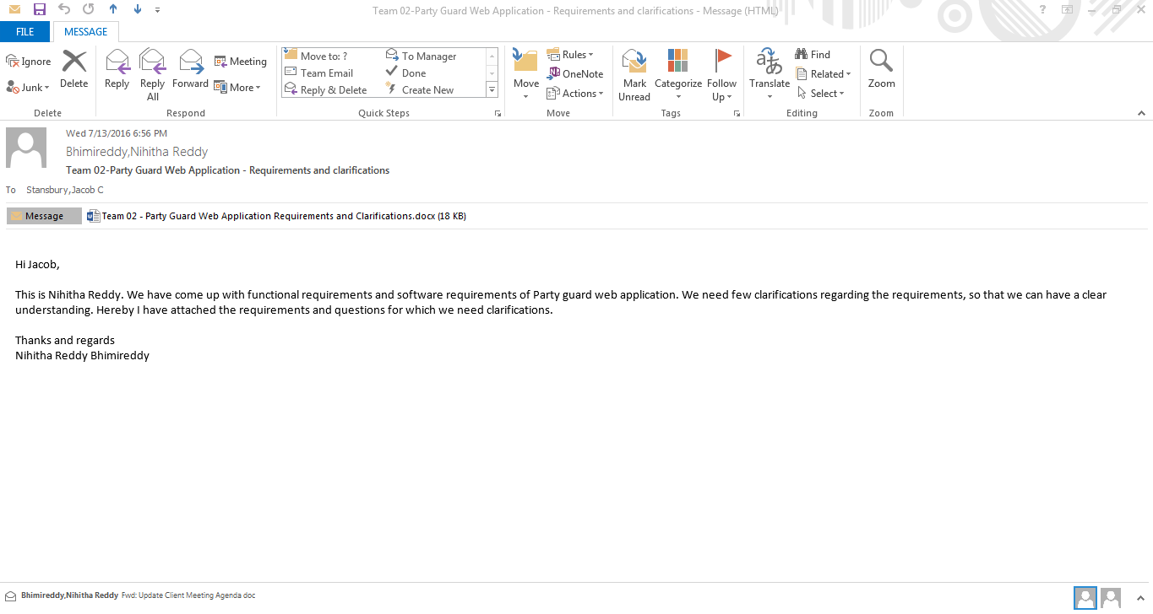

**Client reply**

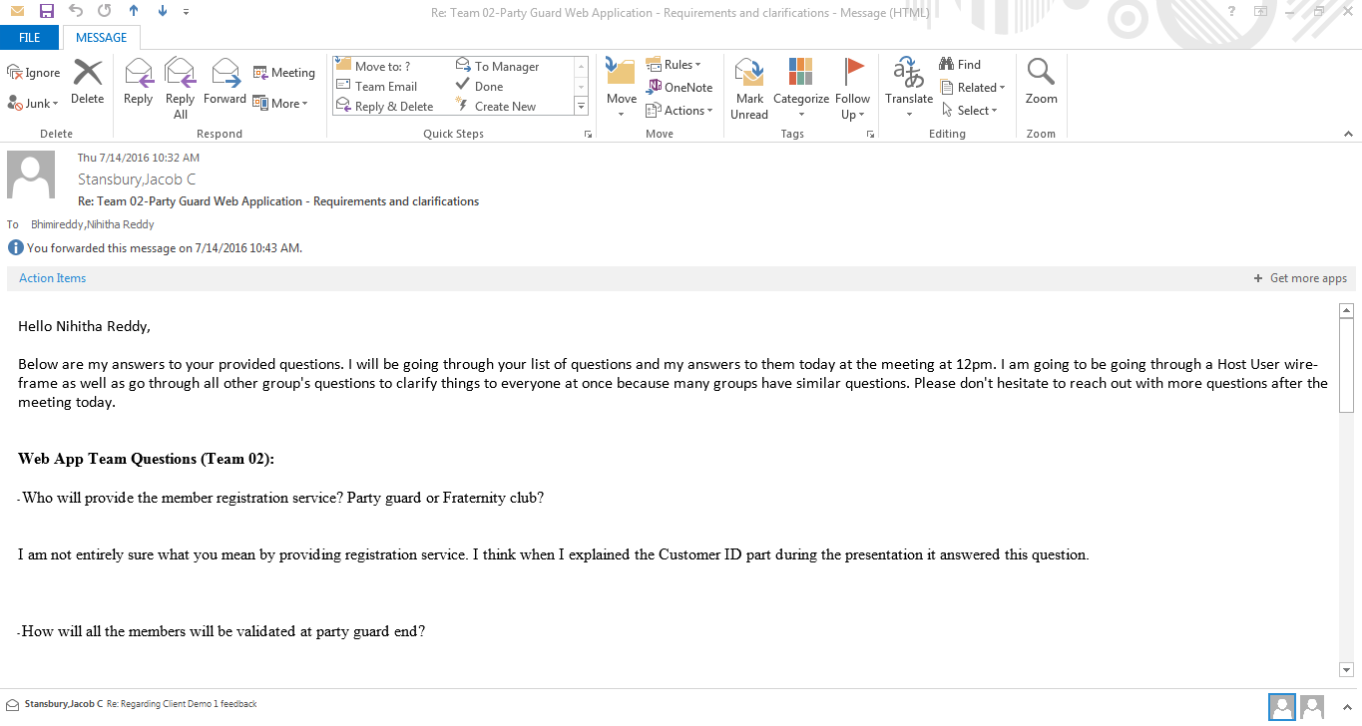



**Client Interaction -1 (Skype Call)**

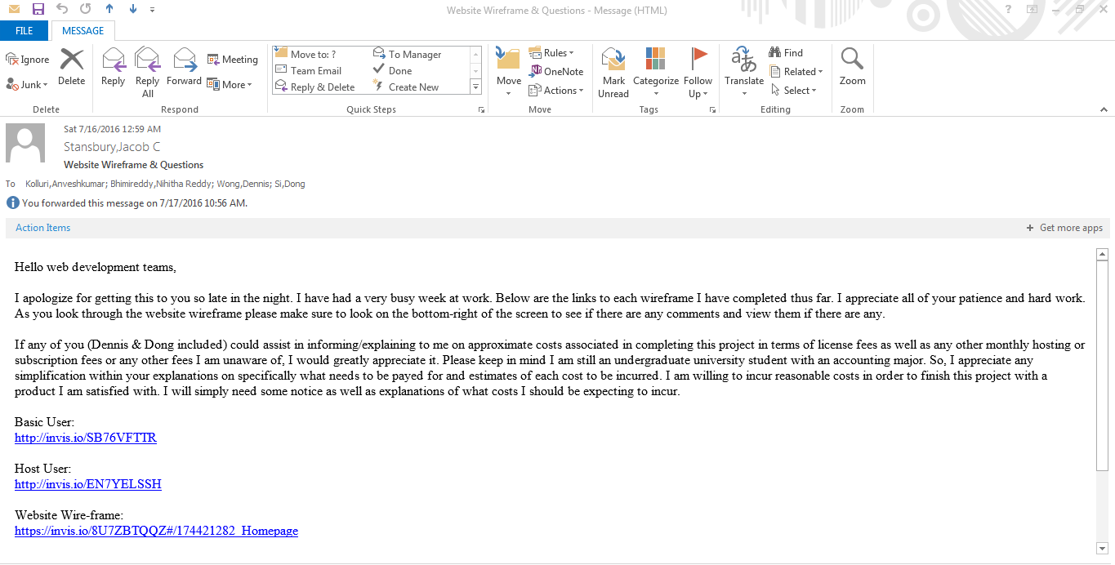



**Client email regarding queries and reply**

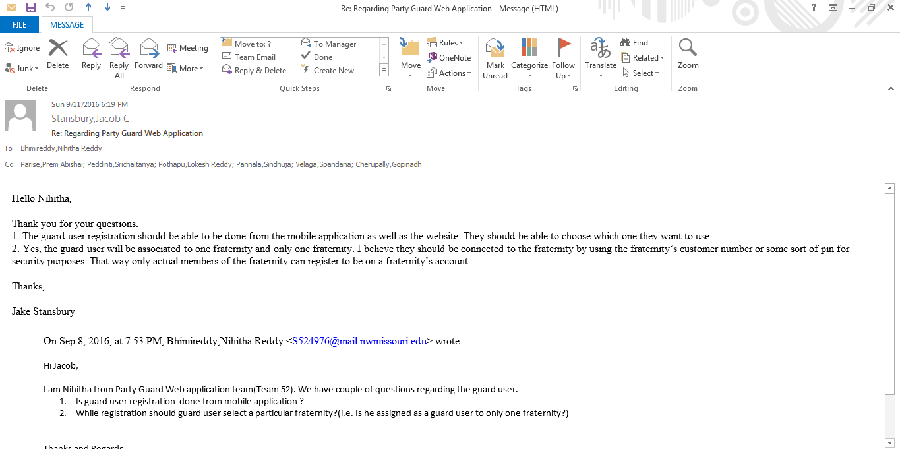



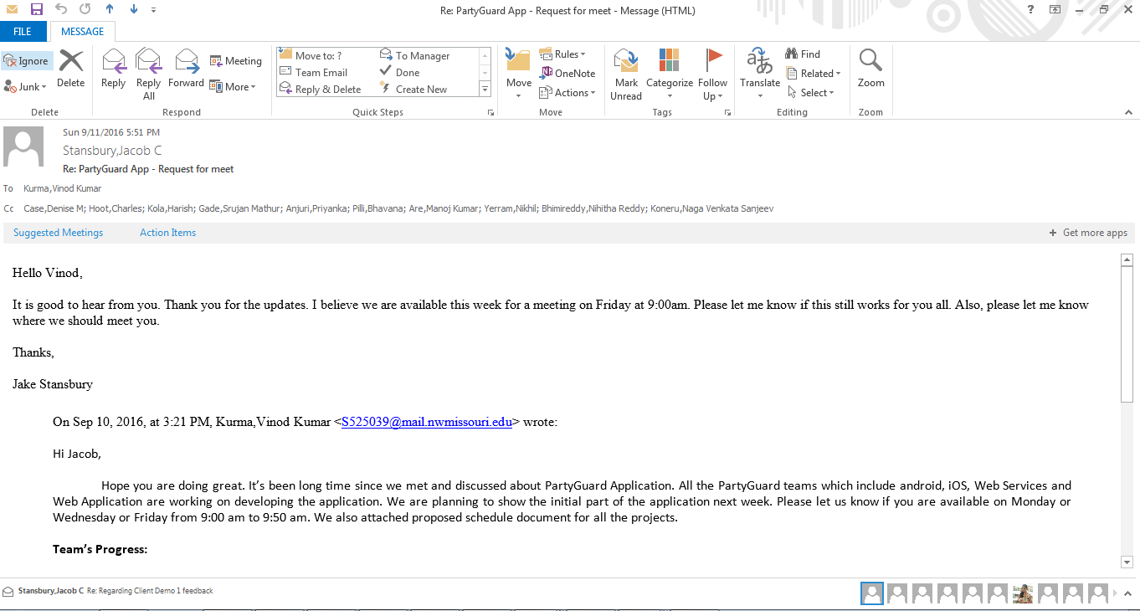



**Client Demo 1 feedback**

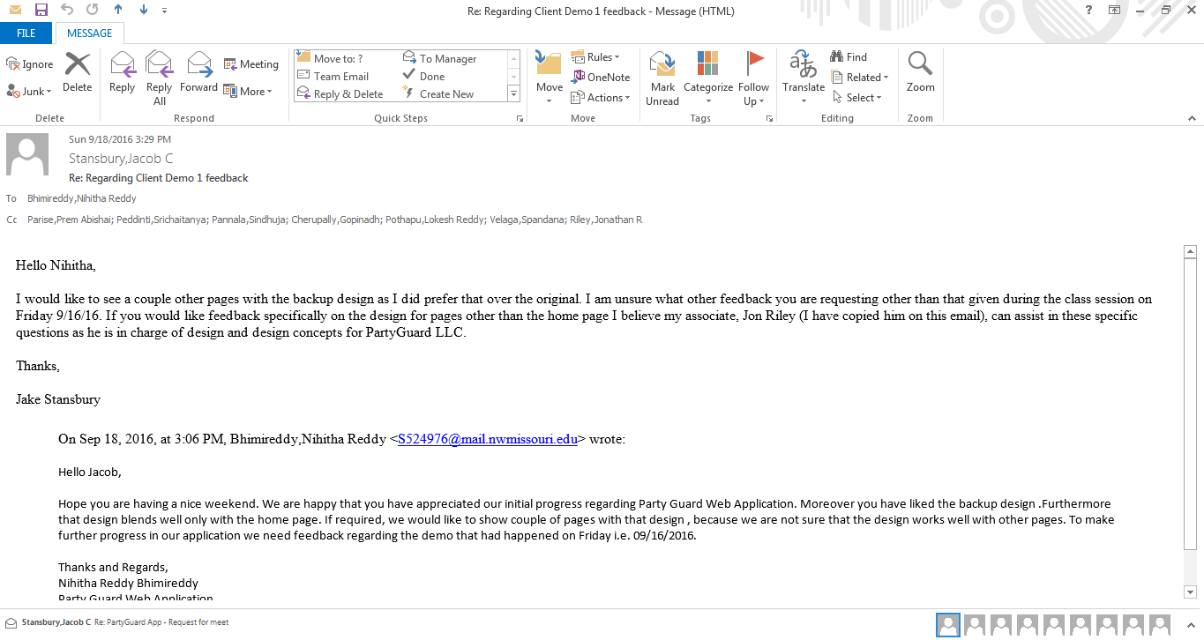



**Client Meeting – Regarding PartyGuard Web Application Design**

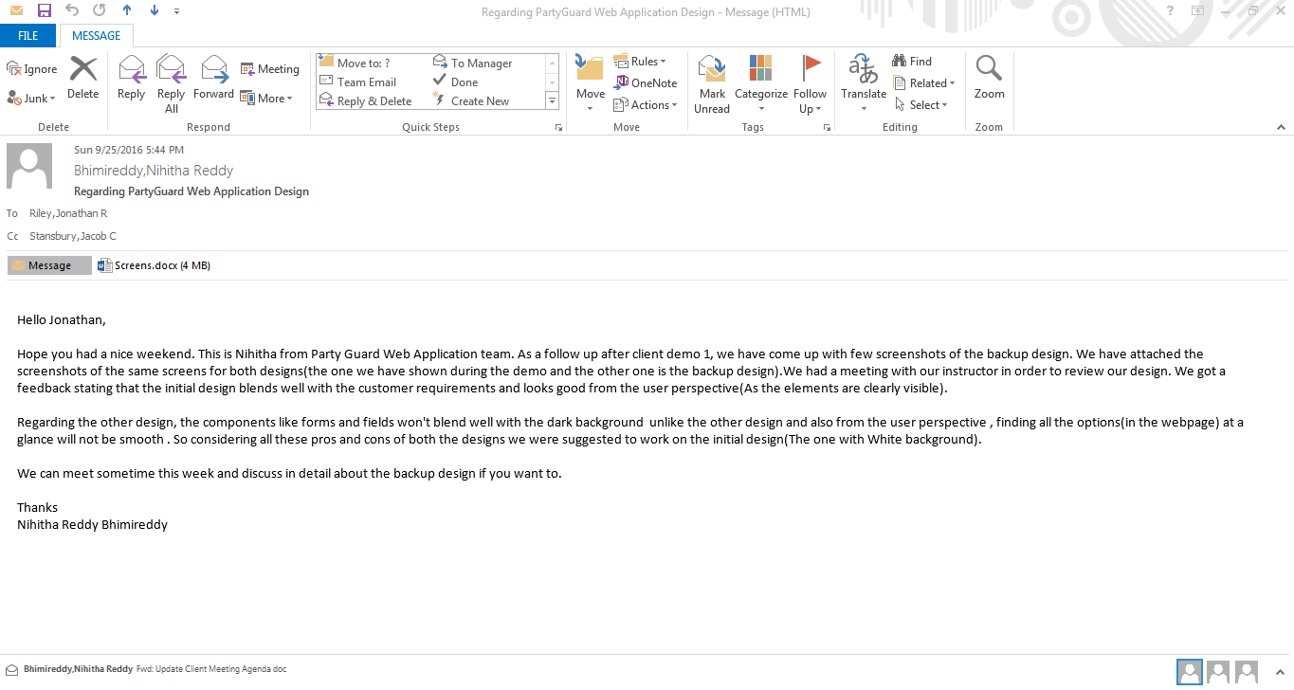



**Meeting Minutes**

* 1. Meeting with Web Services team 
  2. Instructor’s feedback 